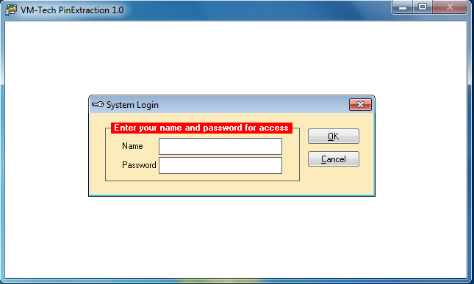
Type ADMIN in the space provided for name and don’t type anything in the space for password as shown below.

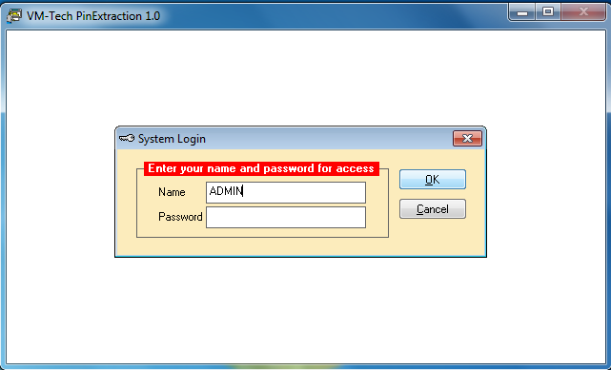

Screen clipping taken: 24/01/2013, 08:10 PM

Then click on the ok button and the next page will appear.

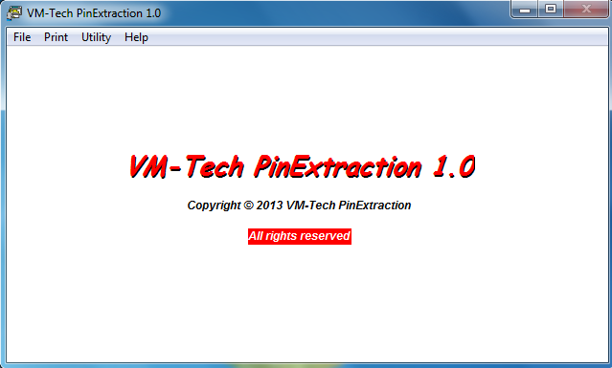

In this page you see the File, Print, Utility and Help.
Help: To learn more about the software click on this.
When you click on File, it will produce the following dropdown.

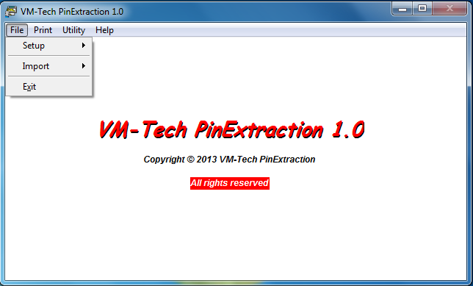

The first thing is setup which is used to setup your business name and address so they can appear on the card when you print as shown below.

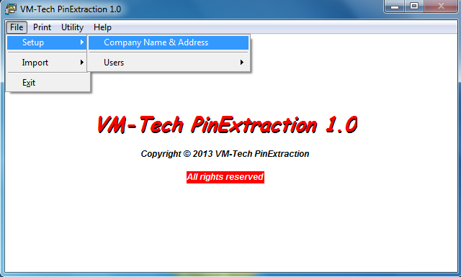

Click on company name & address.

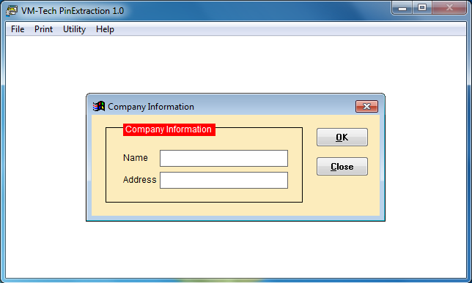

Type your company’s name and address in the spaces provided and click on ok.

Import: this is used to convert or extract scrambled numbers. Click on the import button under file and the following dropdown will appear.

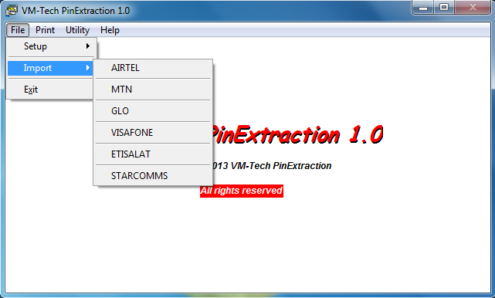

Click on the network you want to extract and the next page will appear.

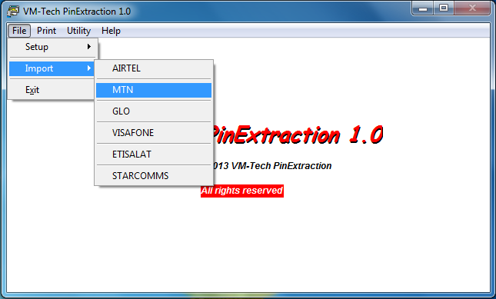

MTN was clicked in this case.

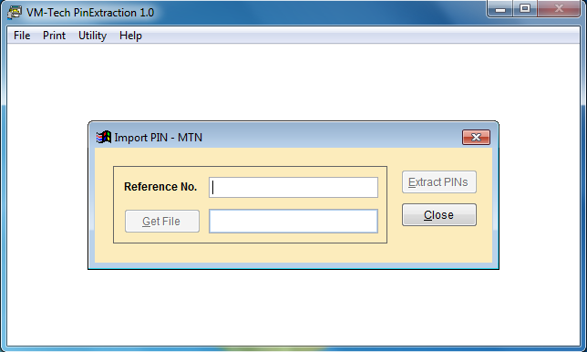

Type anything in the space provided for reference no. and click on get files.

VMTECH

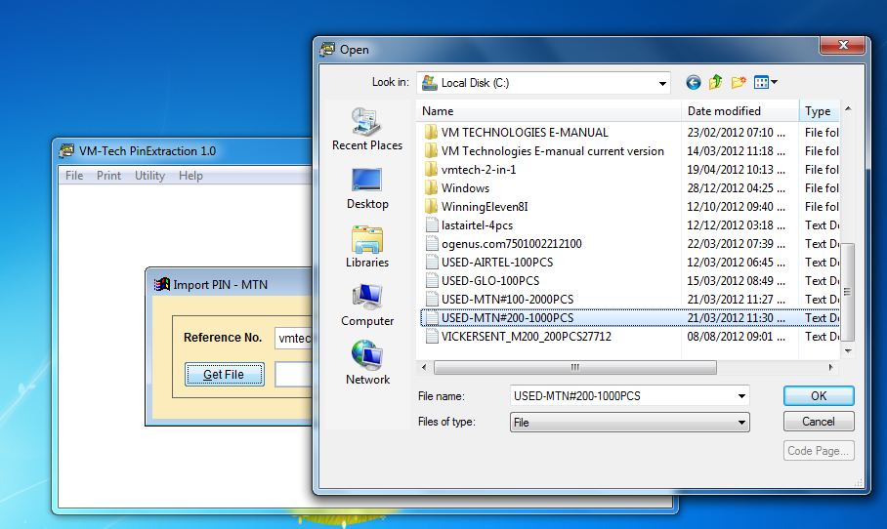

Select the network file you want to print and click ok

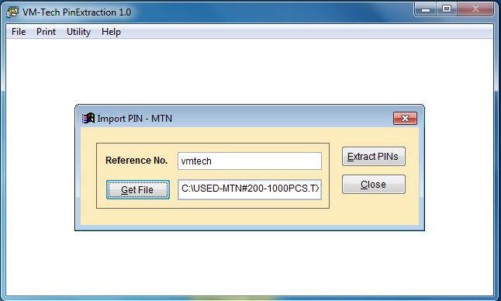

Click on Extract PINs

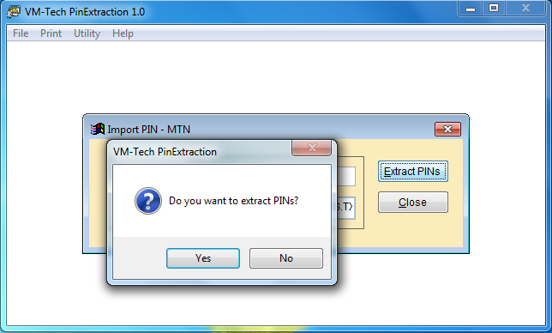

Click on yes.

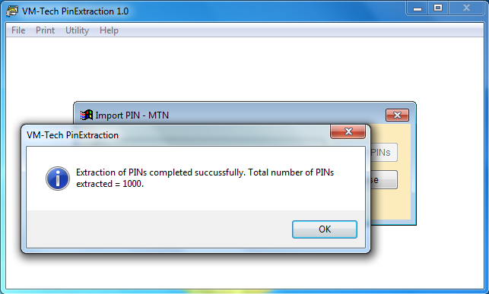

Click on OK.

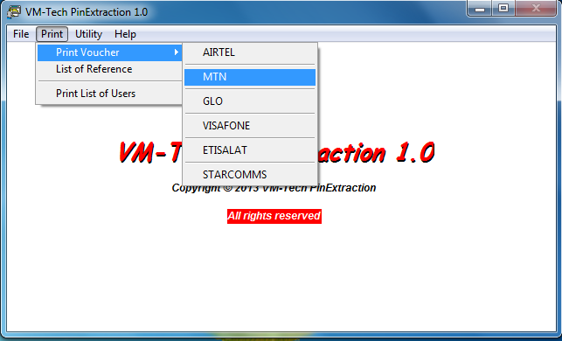
Then click on close. Then go to print and select the same network as shown below.

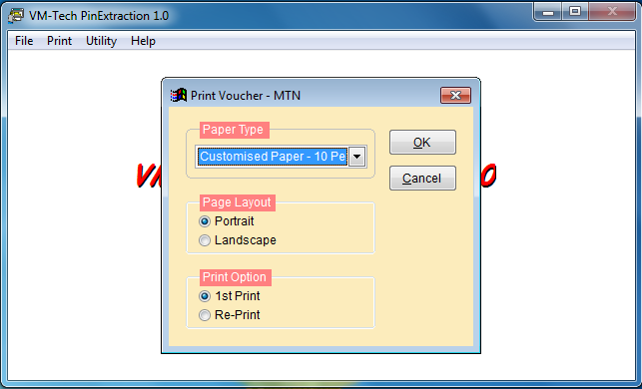

Click on dropdown arrow head by customized paper and select either plain paper 10 per page or plain paper 20 per page.

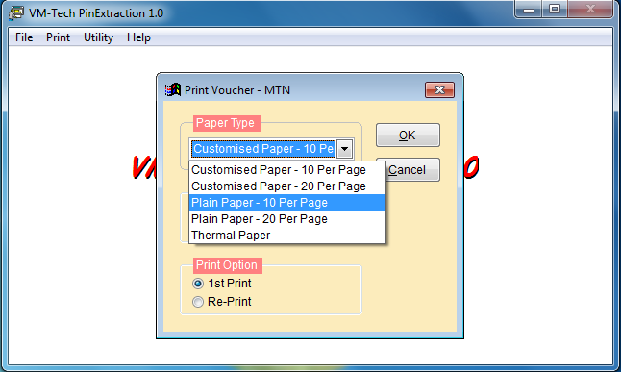

Select either plain paper 10 per page or plain paper 20 per page.

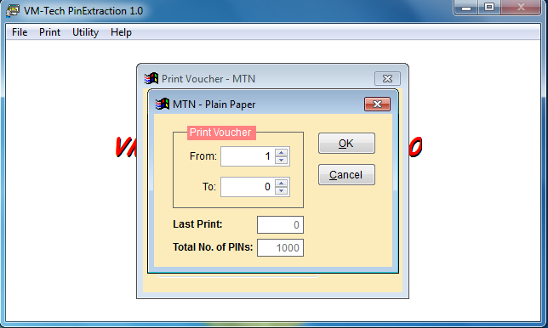

Select the total number you want to print and click on ok.

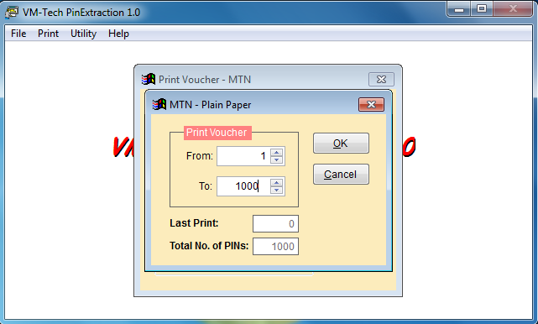

Select the total number you want to print and click on ok.

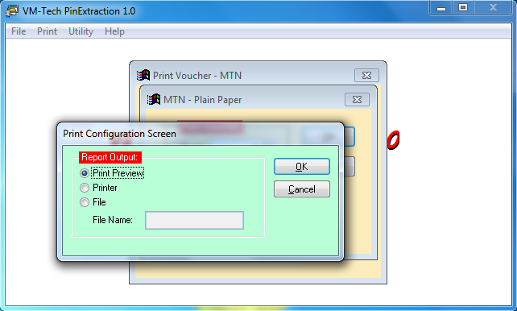

If you just want to see the cards on your computer, you click on print preview else, if your printer is connected you click on printer and print out your cards.

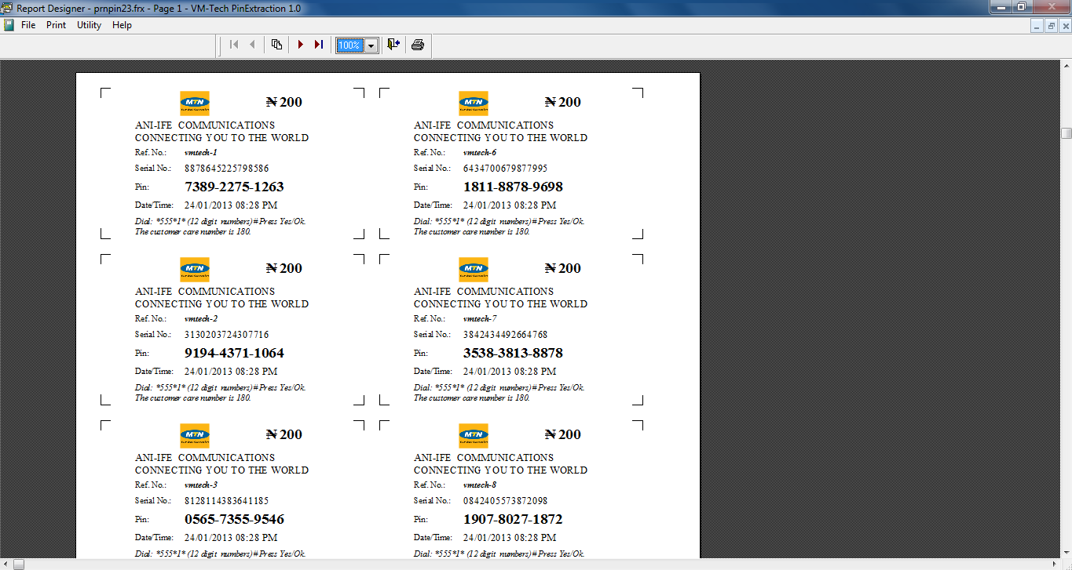

Click on the printer icon above

--Click on the printer icon

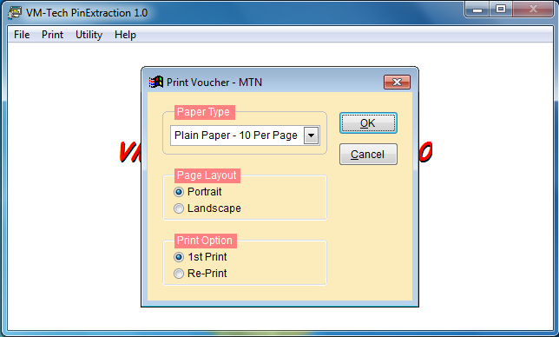

Click on either the red button X or the button Cancel; Do not click on OK

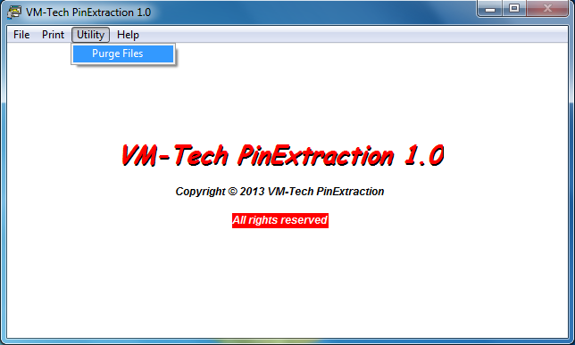

Go to Utility and click on purge files. Note this is a must use after printing

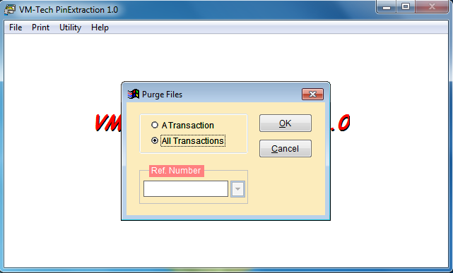

Select all transactions and click on ok.

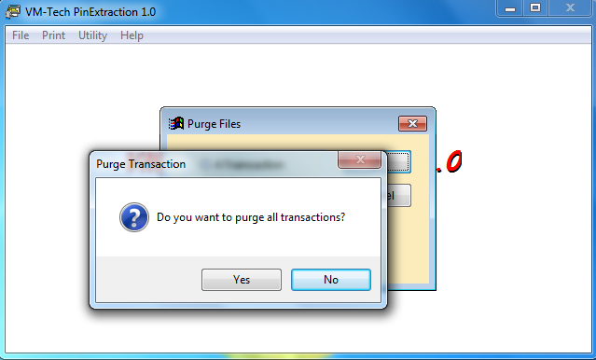

Select yes

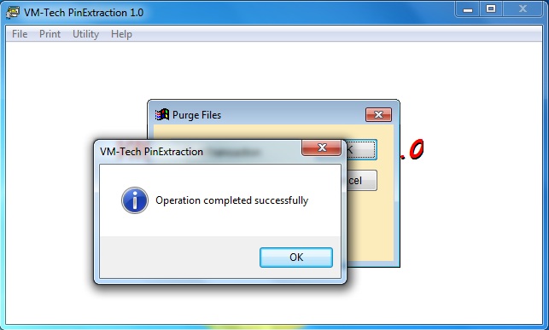

Click ok

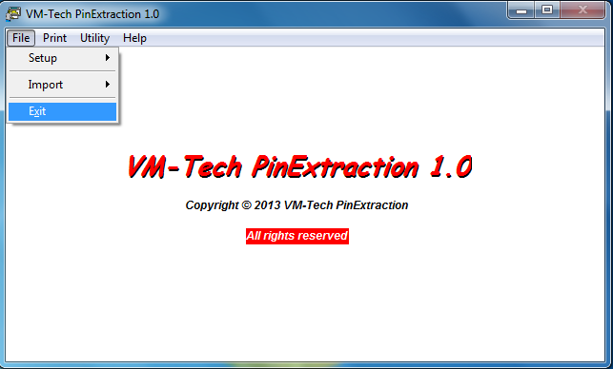

Select Exit to close the application

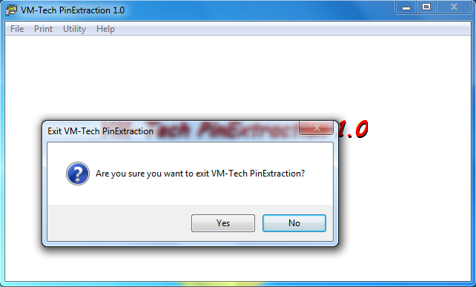

Select ok

